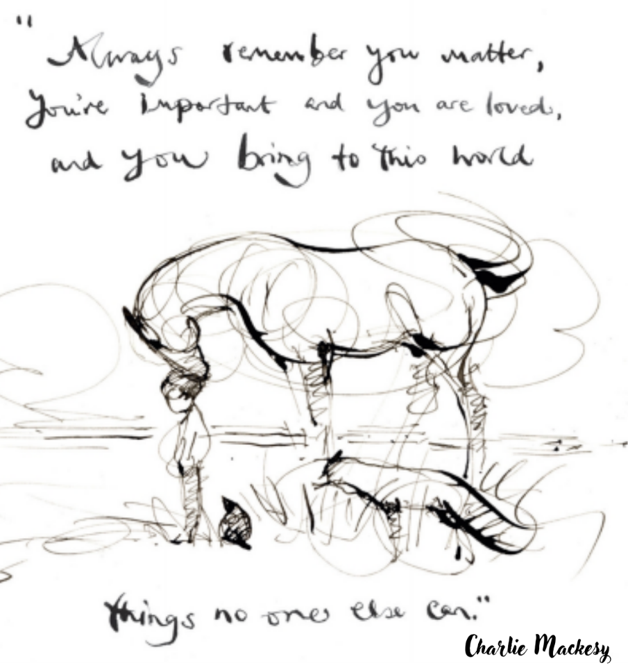

Mental Health Sunday

Sunday June 7, 2026 10:00 AM
Reverend Michelle Sumption Stone

www.uccwebster.org (585) 671-3757
WEBSTER UNITED CHURCH OF CHRIST
June 7, 2026 Mental Health Sunday 10:00 A.M.

As a WISE congregation, we are committed to being Welcoming, Inclusive, Supportive, and Engaged with mental health. We celebrate Mental Health Sunday to remind everyone that no one has to carry their storm alone, and that in this community, you are loved exactly as you are.

Prelude Oleksandra Yurchenko

Words of Welcome WISE Team

Gathering Song “This is the Day” NCH 84
This is the day, this is the day that our God has made, that our God has made; we will
rejoice, we will rejoice and be glad in it, and be glad in it. This is the day that our God
has made, we will rejoice and be glad in it. This is the day, this is the day that our God
has made.

(repeat)

Prayers from the Congregation: "Voices in the Wild"
Leader: In the book, the four friends often sit together in silence before they speak. We’re going to do the same. We will offer three prayers today, inspired by our friends the Fox, the Horse, and the Mole. After the first two, we will keep a quiet silence. But during the second prayer, we invite you to speak your own needs aloud.

I. The Fox’s Prayer: For the Quiet and the Hurt
Focus: Validation of silence and withdrawal.
Leader: We pray for the Foxes among us. For those who feel they have nothing to say, or who have become quiet because the world has been unkind. We pray for those who have withdrawn into the 'thicket' of their own minds to stay safe. May they feel our presence beside them, even if no words are exchanged. We hold space now in silence for those who are struggling quietly...

II. The Horse’s Prayer: For the Courage of "Help"
Focus: Breaking the stigma of self-sufficiency.
Leader: We pray for the Horses among us. For those who are seen as the 'strong ones,' the ones who carry everyone else through the storm. We pray for the heavy-hearted who feel they must keep it all together. Help us to believe what the Horse knows: that asking for help isn't giving up—it's refusing to give up.
Prayers from the Congregation Pastor Michelle

III. The Mole’s Prayer: For the Grace of Self-Kindness
Focus: Silencing the inner critic.
Leader: Finally, we pray for the moles—the part of us that is often so busy looking for 'cake' or a way forward that we forget to be gentle with ourselves. May we accept the Mole’s wisdom: that being kind to ourselves is one of the greatest kindnesses of all. Help us to forgive ourselves for being beautifully, wonderfully human.

Leader: Whether we are the Boy searching for answers, the Mole seeking comfort, the Fox keeping watch, or the Horse offering strength—we are all here. We are all together.
Let us join our hearts and voices in the prayer Jesus taught us—a prayer that asks for what we need for today, and calls us to a deeper kindness.

All: Loving Creator, we honor you, and we honor all that you have made.
Renew the whole world in the image of your love.
Give us what we need for today, and a hunger to see the whole world fed.
Strengthen us for what lies ahead; heal us from the hurts of the past; and give us courage to follow your call in this moment.
For your love is the only power, the only home, the only honor we need, in this world and in the world to come. Amen.
.

Sung Prayer Response “Open My Eyes, That I May See” CH #586

1 Open my eyes, that I may see glimpses of truth Thou hast for me; place in my hands the wonderful key, that shall unclasp and set me free. Silently now I wait for Thee, ready, my God, Thy will to see; open my eyes, illumine me, Spirit divine!

2 Open my ears, that I may hear voices of truth Thou sendest clear; and while the wave-notes fall on my ear, ev’rything false will disappear. Silently now I wait for Thee, ready, my God, Thy will to see; open my ears, illumine me, Spirit divine!

3 Open my mouth, and let me bear gladly the warm truth ev’rywhere; Open my heart, and let me prepare love with Thy children thus to share. Silently now I wait for Thee, ready, my God, Thy will to see; open my mouth, illumine me, Spirit divine!

Greeting One Another with God’s Peace (a wave, a nod, a sign of peace…)
“May the Peace of Christ be with you.” “And also with you.”

Choral Anthem "Lean On Me/Everlasting Arms"- Pepper Choplin Ron Milliman, Director

Offering
Invitation
Offertory “Flower Duet” from Lakme for Two Flutes and Piano by Leo Delibes
Arranged by Jeanne Baxtresser and Margaret Baxtresser
Flutes Mia Lubkowski, Marcia Kendrick
Piano Oleksandra Yurchenko
Prayer of Gratitude and Dedication

Reading “Walking Each Other Home” The Boy, the Mole, the Fox and the Horse
by Charlie Mackesy

Introduction: The Map of the Wild
Speaker: In the wild of our own lives - especially when we are navigating the landscape of mental health - we often feel like we need a map. We want a clear path out of the woods. But Charlie Mackesy’s book suggests that we don't need a map as much as we need a 'who.'
We need a Boy to ask the questions, a Mole to offer kindness, a Fox to stay when things are quiet, and a Horse to carry us when we are weary. Today, we look at how these four parts of ourselves talk to one another when the 'storm' hits.

Movement 1: The Mole and the Kindness of "Cake"
Reader 1:
"I've discovered something better than cake," said the mole. "What?" asked the boy. "A hug. It lasts longer." "Being kind to yourself is one of the greatest kindnesses," said the mole.
Speaker: We start with the Mole because the Mole understands nourishment. In the world of mental health, we are often our own harshest critics. We compare our 'inside' mess to everyone else's 'outside' polish. The Mole reminds us that self-compassion isn't a luxury—it’s survival. Whether it’s a literal piece of cake, a long nap, or simply stopping the internal lecture for five minutes, being kind to yourself is the first step toward home. It’s the realization that you don't have to 'earn' your worthiness.

Movement 2: The Fox and the Value of Truth
Reader 2:
"To be honest, I often feel I have nothing interesting to say," said the fox. "Being honest is always interesting," said the horse. "To be honest, I often feel lost," said the boy. "Me too," said the mole, "but we love you, and love brings you home."
Speaker: Then there is the Fox. The Fox is the part of us that has been hurt, and because of that, the Fox is wary. Many of us come to this service today feeling a bit like the Fox. We might feel 'lost,' or we might feel like our struggles make us 'uninteresting' or a burden to others.
But look at what happens: the Fox’s honesty allows the Boy to say, 'I'm lost too.' Mental health thrives in the dark, but it begins to heal the moment we are 'interesting' enough to be honest. We don't need to be cured to be loved; we just need to be present.

Movement 3: The Horse and the Bravest Word
Reader 3:
"What is the bravest thing you've ever said?" asked the boy. "Help," said the horse. "Asking for help isn't giving up," said the horse. "It's refusing to give up."
Speaker: This is the turning point of our story. The Horse is the biggest, strongest character in the group, yet he is the very one who admits to needing help.
In our culture we are taught that 'strong' means 'silent.' We think we have to carry everything on our own shoulders. We try to quietly manage the worries of our families, the changing dynamics of our health, the keeping up of our homes, and the heavy weight of grief all by ourselves.
But the Horse tells us a different truth: Asking for help is not a sign of weakness. It is an act of courage. It is a declaration that you intend to keep going. If you are here today and you are tired from carrying the weight of the years or the worries of life, let the Horse speak for you. There is no shame in the hand—or the hoof—that reaches out for support.

Movement 4: The Storm and the Journey’s End
Reader 4:
"The storm is passing," said the horse. "How do you know?" asked the boy. "Because we are still here." "We have a long way to go," sighed the boy. "Yes, but look how far we've come," said the horse.
Speaker: Our journey with our thoughts and feelings is a long road, much like the one these four friends are walking. Like the Boy says, sometimes it feels like we have a long way to go. There will be more storms. But the miracle is that we are still here. We have survived every 'worst day' we have ever had.
And we haven't done it by being perfect. We’ve done it by putting one hoof in front of the other, together. We are travelers, and we are neighbors, and most importantly, we are companions.
Message “Here” Pastor Michelle

Transition to Communion “Companions on the Journey” NCH #472
Refrain
We are companions on the journey,
Breaking bread and sharing life;
And in the love we bear is the hope we share
for we believe in the love of our God,
We believe in the love of our God.

Verse 1
No longer strangers to each other,
No longer strangers in God’s House;
We are fed and we are nourished
by the strength of those who care,
By the strength of those who care.
Refrain

Verse 2
We have been gifted each other,
And we are called by the Word of the Lord:
To act with justice, to love tenderly
And to walk humbly with our God,
To walk humbly with our God.
Refrain

Communion
The Invitation (The Boy’s Curiosity): The Boy asks: 'What is the bravest thing you've ever said?' The Horse answers: 'Help.' We come to this table because we are brave enough to admit we need help. We need nourishment. We need each other.
The Blessing (The Mole’s Kindness): We bless this bread, remembering the Mole’s wisdom that 'being kind to yourself is one of the greatest kindnesses.' May this meal be an act of kindness to your own soul.
The Peace (The Fox’s Presence): The Fox didn't say much, but he stayed. As we share this meal, we offer each other the 'Fox’s Peace'—the gift of just being here, together, through the storm.
The Shared Cup (The Horse’s Wisdom): The Horse says: 'Always remember you matter.' As we share this cup, we remember that every person in this room matters, is important, and is loved.

Song “Walk With Me” TFWS #2242

Refrain: Walk with me and I will walk with you and build the land that God has planned where love shines through.

When Moses heard the call of God he said, “Lord, don’t send me.” But God told Moses “You’re the one to set my people free.” (Refrain)

Now Peter was a most unlikely man to lead the flock; But Jesus knew his holiness and he became the Rock. (Refrain)

Young Mary Magdalene was sure her life could be much more, And by her faith she dared to let God’s love unlock the door. (Refrain)

And when you share your faith with me and work for life made new, the witness of your faithfulness calls me to walk with you. (Refrain)

Announcements

Benediction

Sung Congregational Benediction “Draw the Circle Wide”
Refrain: Draw the circle wide, draw it wider still. Let this be our song: no one stands alone standing side by side. Draw the circle wide.

God the still point of the circle, round whom all creation turns; nothing lost but held together in God’s gracious arms. (Sing Refrain)

Let our hearts touch far horizons, so encompass great and small; let our loving know no
borders, faithful to God’s call. (Sing Refrain)

Let the dream we dreamed be larger than we ever dreamed before; let the dream of Christ be in us, open every door. (Sing Refrain)

Postlude Oleksandra Yurchenko

Serving you this morning:
Reader – WISE Team Livestream – Ken Mihalyov
Greeter— Carole Haas

Character Key:
The Boy: The one who asks the questions.  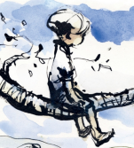 | The Mole: The one who loves kindness (and cake)  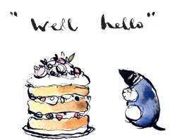
The Fox: The one who has been hurt and is quiet  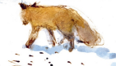 | The Horse: The big, wise one who offers strength  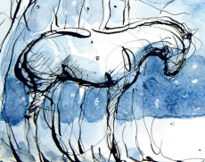

ANNOUNCEMENTS 6/7/26

Spring Annual Meeting
PLEASE TAKE NOTICE that a Congregational Meeting will be held on June 14 in the sanctuary immediately following the worship service. At that time, the members of Wester United Church of Christ, Congregational will be asked to elect persons to fill leadership positions and to conduct any other business that may properly come before the meeting.
This year, there are five Leadership Council positions up for election. Many of the current office holders are willing to serve another term or have identified potential replacements; however, we also welcome additional candidates who may feel called to serve.
Please let us know if you are interested in running for an elected position. These leaders help make decisions on behalf of the congregation between annual meetings. If you have wanted to have more input into how the church operates, this is a meaningful opportunity to participate.
If you would be interested in “shadowing” a current council member to explore whether a role might be a good fit for you in the future, please let us know as well. Every one of us can use an extra set of eyes, ears, and hands.

Positions Up for Election
- Building and Grounds (Current candidate: Pete Sollame)
- Stewardship Need one additional person
- Mission (Current candidate: Jeff Peck)
- Personnel (Current candidate: Ken Mihalyov)
- Worship (Current candidate: Heather Himes)
- Investment Team (Current candidates: Tom Hopkins, Rick Ashley) One more needed
- Treasurer (Current candidate: Judy Short)
FREE COMMUNITY SUNDAY SUPPER- June 14 4:30-5:30. Everyone is welcome. The menu is …. Grilled Sausage, Pasta Salad, Corn & Eclairs. Contact Wendy wlesko88@gmail.com if you’d like to volunteer
STRENGTHEN THE CHURCH the 2nd of 4 special UCC offerings will be received during June. As God calls our congregation to be the church in new ways, your donations will plant new churches, awaken new ideas in existing churches, and develop the spiritual life in our youth and young adults. Please note STC on check.
RAINFOREST FALLS VBS June 29-July 3 9:00-12:00
PROJECT IMPACT- Youth Mission June 29-July 2 12:30-2:30
CARING COMMUNITY CONCERTS: July 8, July 15, July 22, July 29, August 5
PRIDE PARADE Saturday July 18
SHINE minicamp: August 3- August 5

ONGOING
HOT TOPICS: The Hot Topics discussion group will meet next on Tuesday, June 16, at 6:30 p.m. in the Sanctuary. We will discuss "Walking the walk: how do we live our values and ought we live our values." This will be our last meeting until Tuesday, September 1. We will be on break for July and August. For more information or to be added to our e-mail distribution list, contact richard_kendrick@verizon.net.
MEDITATION GROUP- Wednesdays at 11:00 a.m. in the back of the Sanctuary. All are welcome! Note…will not meet in July and August
The Nurture Team: is a group of caring individuals who express the love of God through their Ministry of Care. They hope to walk with those in need of company or pray. They liaison with the pastor if a pastoral visit is desired. If you have a concern or need of prayer or if you know someone who does, please put a note in the offering plate.
PRAYER SHAWL: This group does not formally meet. It’s for anyone who wants to knit or crochet prayer shawls to be given to people in need of comfort and/or dish cloths for outreach grocery bags given to people in need. contact Wendy wlesko88@gmail.com
INFORMATION FOR THE NEWSLETTER should be directed to Wendy Lesko wlesko88@gmail.com by the 25th of the month
ANNOUNCEMENTS EMAIL LIST If you’d like to receive email notifications from church, you can join our email list. There’s a link on the church website under “Connect with Us”. https://uccwebster.org/connect-with-us/ Enter your email address and hit “subscribe.”
FLOWERS for the communion table – sign-up in the hallway. One arrangement per Sunday. You can bring your own flower arrangement or pay for the florist to deliver one. Please pay in advance. Leave payment in church office or give to Heather Himes.
CLOTHING & SMALL HOUSEHOLD ITEMS Please place the items in the 2 bins located in the hall near the West Entrance. Items are distributed to Cameron Community, Matthew's Closet, or Saints Place. Thank You!
THE ROCKERS This is a group of the mature men from our congregation that meets on the 1st and 3rd Thursday each month at 8:30am at The Nutcracker Restaurant
COFFEE HOUR Volunteers are needed to sign up to coordinate a week (make the coffee, provide a treat). If you are interested, please contact Heidi Zastowny (heidizastowny@gmail.com; (585) 314-0678) or Diane Cannarozzo (dcannaro@gmail.com).

IN THE COMMUNITY

COMMUNITY SERVICE CAMP: July 13-July 15 9:00-12:00
PET FOOD NEEDED: The pet food pantry needs donations of dry and canned cat food and dog food. A collection basket is in the narthex. Thank you

